Overview
This file is a specification of the model created by UML definition

asn4 Package

Stereotype

Definition

Relation (From Source To Target)

Relation (From Target To Source)

Diagram

asn4::House Mate Entitlement Service[Class Diagram]

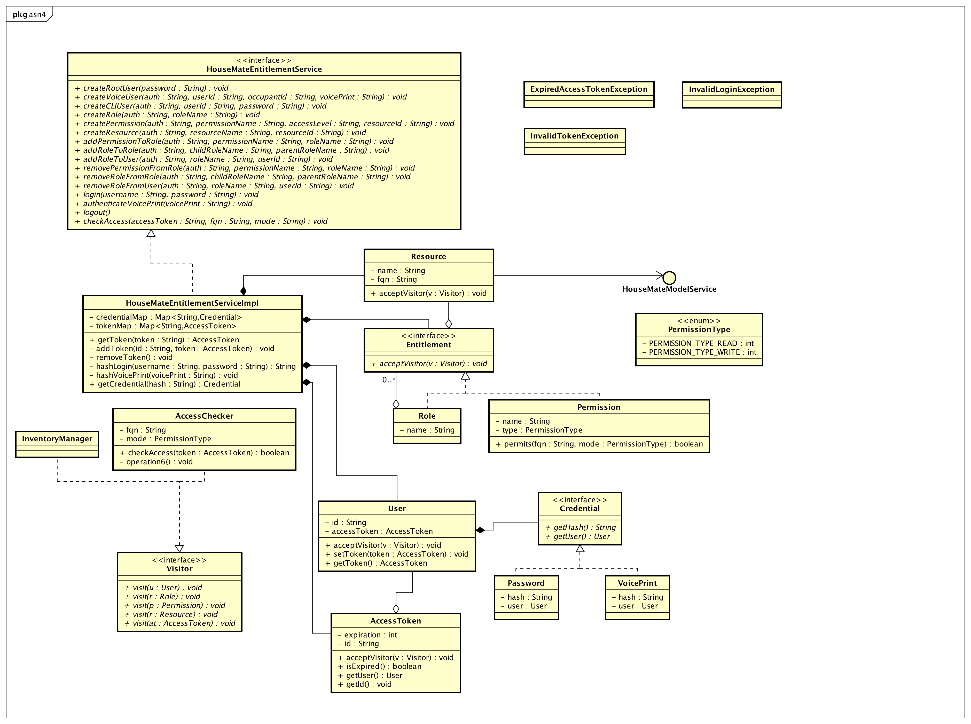

figure 1: asn4::House Mate Entitlement Service[Class Diagram]

Definition

Custom Property
Name | Value

asn4::Check Access[Sequence Diagram]

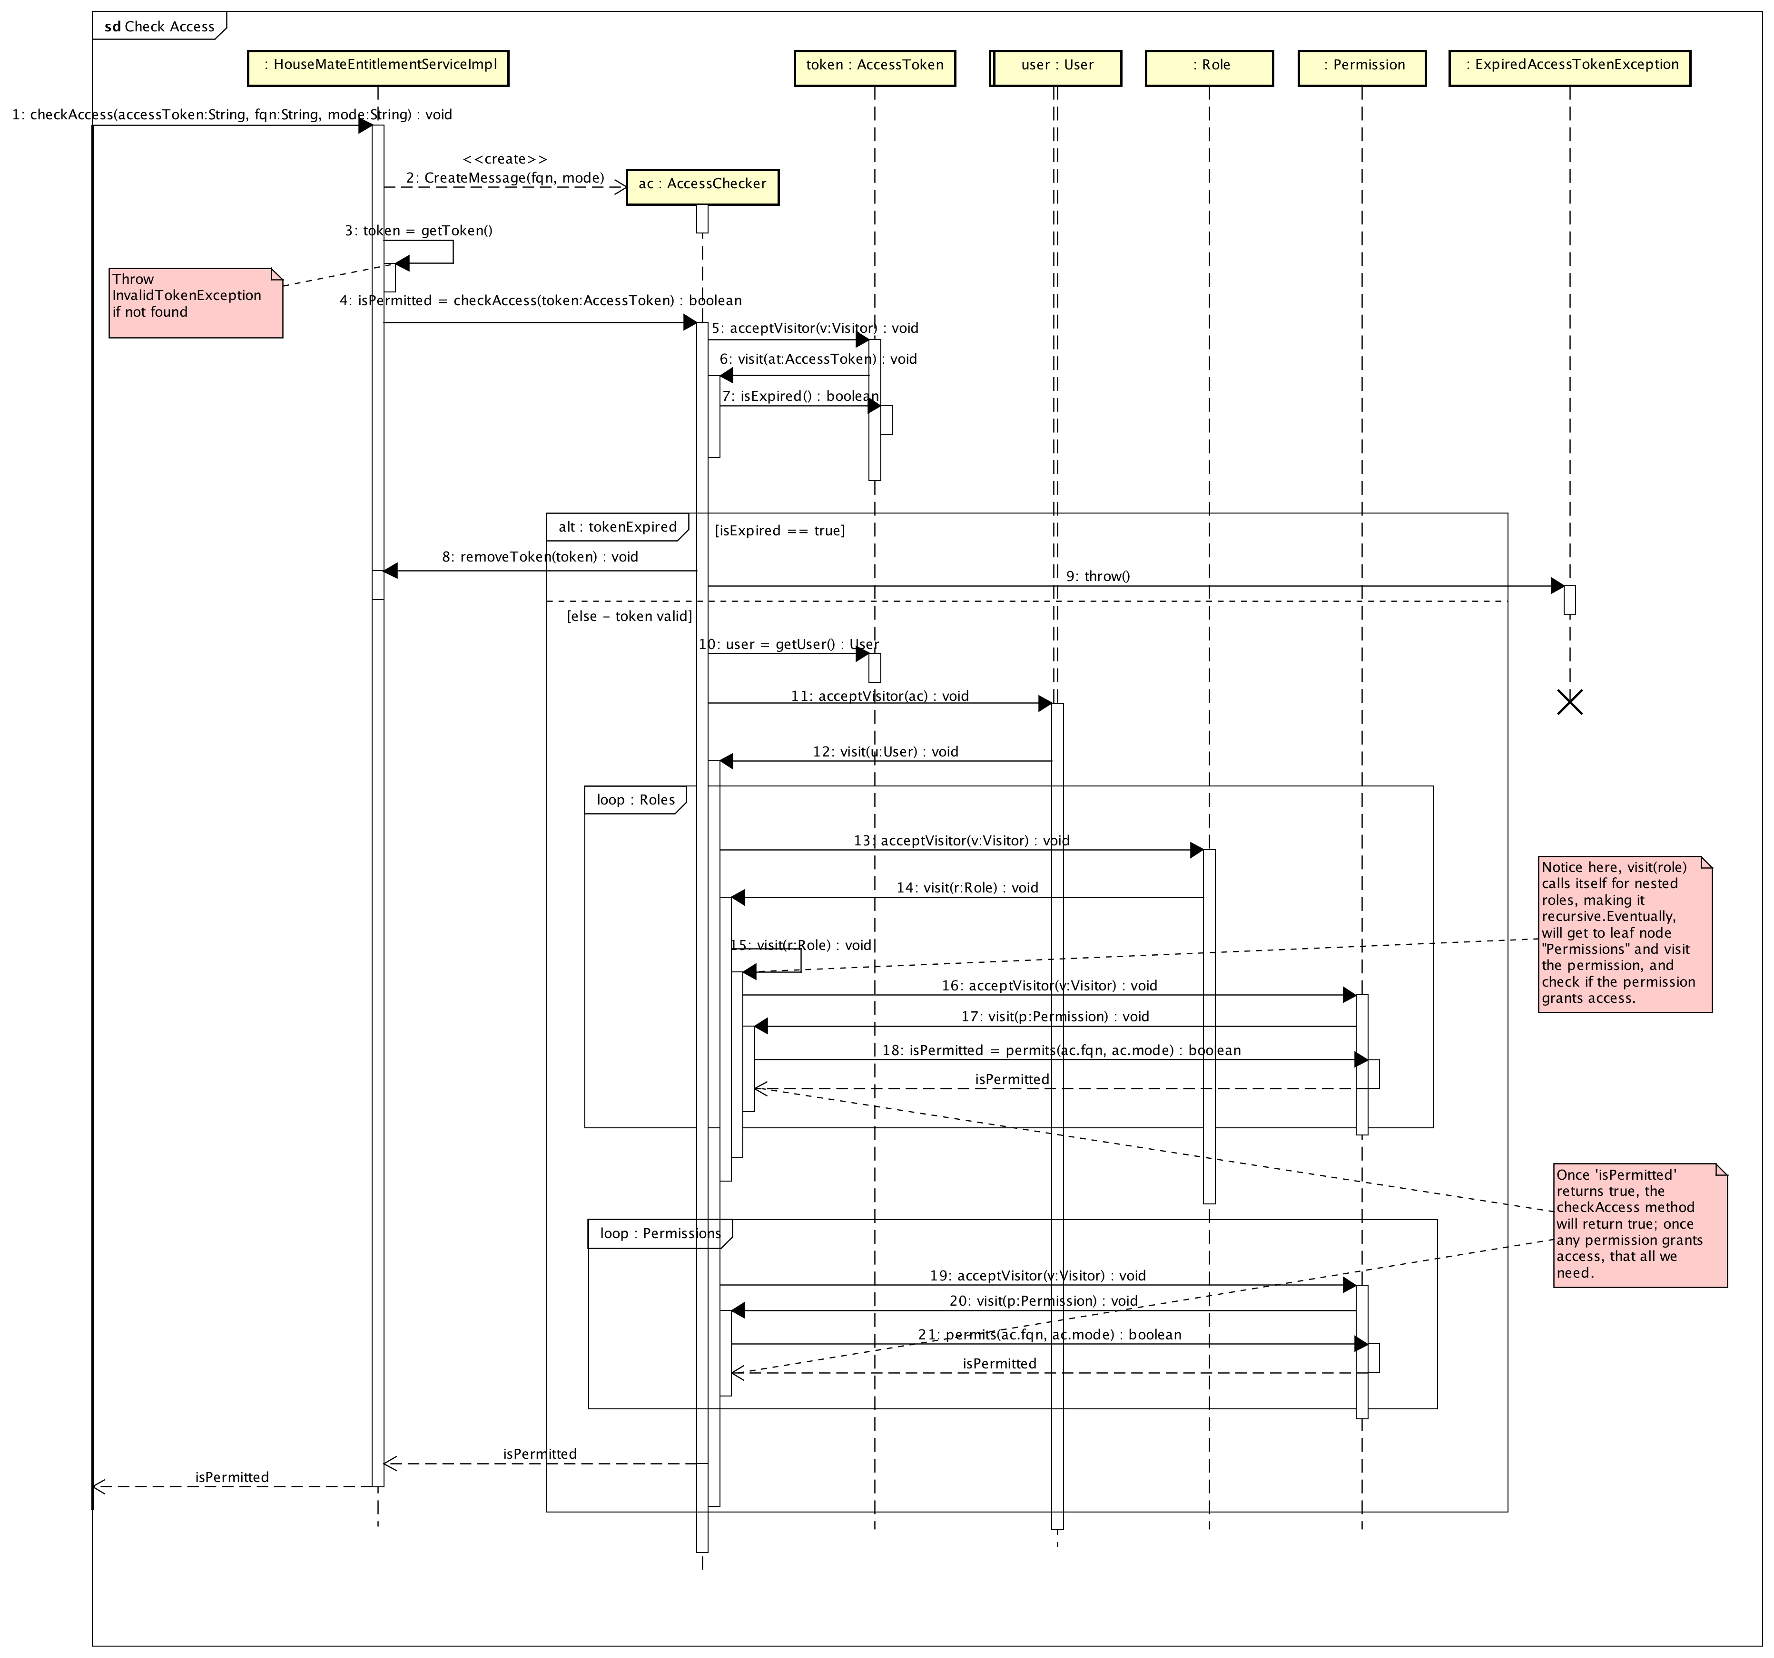

figure 2: asn4::Check Access[Sequence Diagram]

Definition

Custom Property
Name | Value

asn4::Invoke Protected Voice Command[Sequence Diagram]

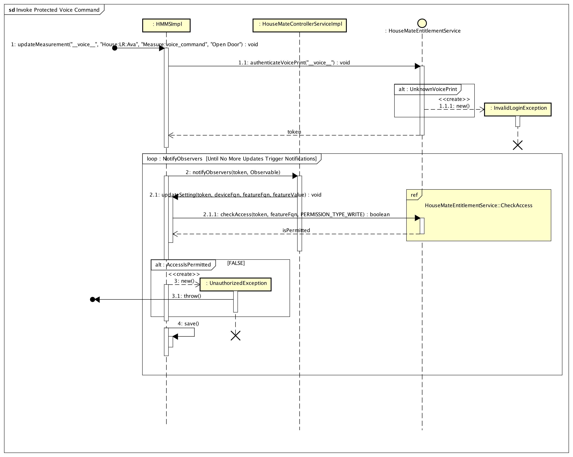

figure 3: asn4::Invoke Protected Voice Command[Sequence Diagram]

Definition

Custom Property
Name | Value

asn4::Login[Sequence Diagram]

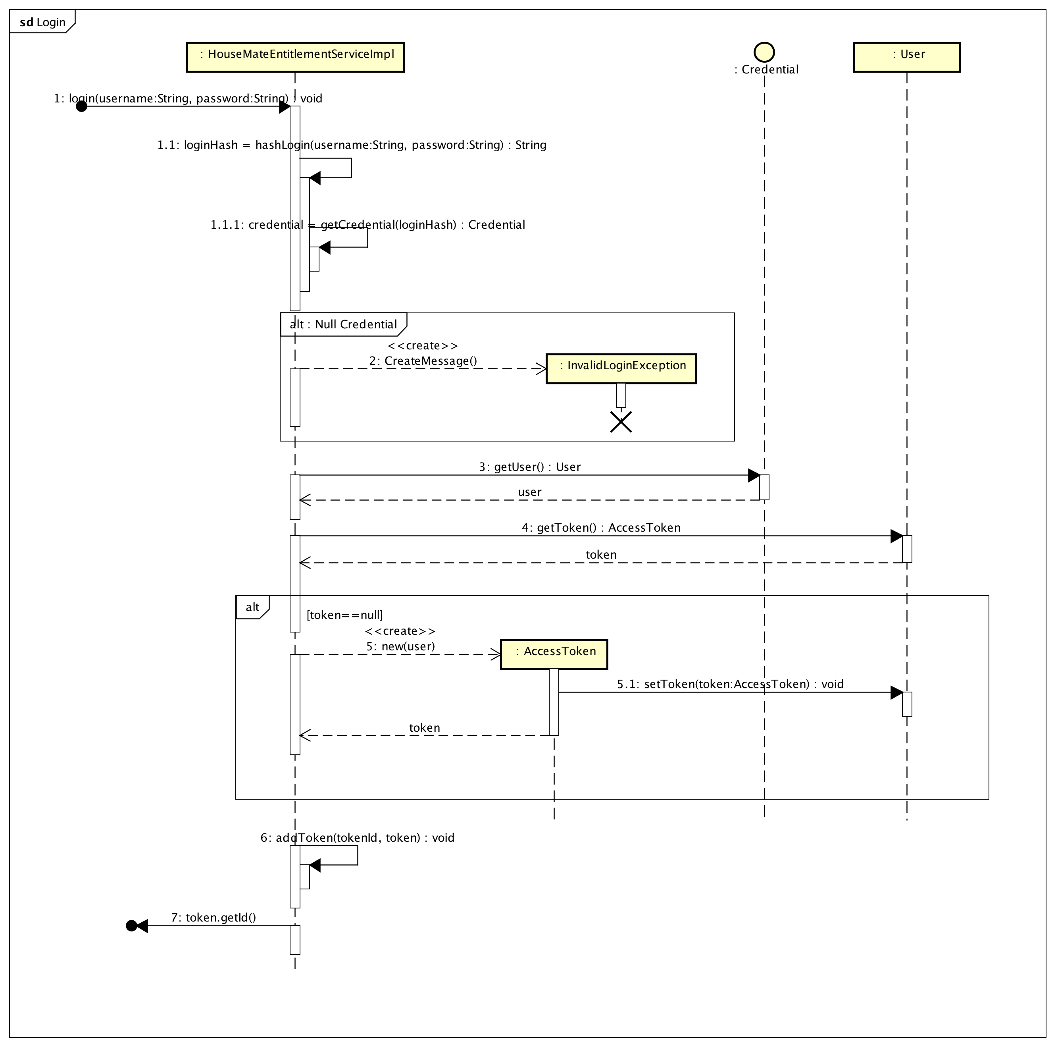

figure 4: asn4::Login[Sequence Diagram]

Definition

Custom Property
Name | Value

Hierarchy Structure of Activity Diagram

Hierarchy Structure of Data Flow Diagram

UseCase

Class

AccessChecker [Class]

Declaration
public class AccessChecker
implements Visitor

Namespace
asn4

Stereotype

Constraint

Definition

Template Parameter

Attribute
Name | Type | Summary
fqn | private String
mode | private PermissionType

Operation
Name | Type | Summary
checkAccess  (AccessToken) | public boolean  [Parameters]  in token: AccessToken
operation6 | private void

Relation (From Source To Target)
Name | Type | Target | Summary
 | Realization | Visitor

Relation (From Target To Source)

Custom Property
Name | Value

AccessToken [Class]

Declaration
public class AccessToken

Namespace
asn4

Stereotype

Constraint

Definition

Template Parameter

Attribute
Name | Type | Summary
expiration | private int
id | private String

Operation
Name | Type | Summary
acceptVisitor  (Visitor) | public void  [Parameters]  in v: Visitor
isExpired | public boolean
getUser | public User
getId | public void

Relation (From Source To Target)
Name | Type | Target | Summary
 | Association | User
 | Association | User
 | Association | User

Relation (From Target To Source)

Custom Property
Name | Value

Checkable [Class]

Declaration
public class Checkable

Namespace
asn4

Stereotype

Constraint

Definition

Template Parameter

Attribute

Operation

Relation (From Source To Target)

Relation (From Target To Source)

Custom Property
Name | Value

Class13 [Class]

Declaration
public class Class13

Namespace
asn4

Stereotype

Constraint

Definition

Template Parameter

Attribute

Operation

Relation (From Source To Target)

Relation (From Target To Source)

Custom Property
Name | Value

Class15 [Class]

Declaration
public class Class15

Namespace
asn4

Stereotype

Constraint

Definition

Template Parameter

Attribute

Operation

Relation (From Source To Target)

Relation (From Target To Source)

Custom Property
Name | Value

Class16 [Class]

Declaration
public class Class16

Namespace
asn4

Stereotype

Constraint

Definition

Template Parameter

Attribute

Operation

Relation (From Source To Target)

Relation (From Target To Source)

Custom Property
Name | Value

Class2 [Class]

Declaration
public class Class2

Namespace
asn4

Stereotype

Constraint

Definition

Template Parameter

Attribute

Operation

Relation (From Source To Target)

Relation (From Target To Source)

Custom Property
Name | Value

Class21 [Class]

Declaration
public class Class21

Namespace
asn4

Stereotype

Constraint

Definition

Template Parameter

Attribute

Operation

Relation (From Source To Target)

Relation (From Target To Source)

Custom Property
Name | Value

Class3 [Class]

Declaration
public class Class3

Namespace
asn4

Stereotype

Constraint

Definition

Template Parameter

Attribute

Operation

Relation (From Source To Target)

Relation (From Target To Source)

Custom Property
Name | Value

Class4 [Class]

Declaration
public class Class4

Namespace
asn4

Stereotype

Constraint

Definition

Template Parameter

Attribute

Operation

Relation (From Source To Target)

Relation (From Target To Source)

Custom Property
Name | Value

Class7 [Class]

Declaration
public class Class7

Namespace
asn4

Stereotype

Constraint

Definition

Template Parameter

Attribute

Operation

Relation (From Source To Target)

Relation (From Target To Source)

Custom Property
Name | Value

Credential [Interface]

Declaration
public class Credential

Namespace
asn4

Stereotype
<<interface>>

Constraint

Definition

Template Parameter

Attribute

Operation
Name | Type | Summary
getHash | public String
getUser | public User

Relation (From Source To Target)
Name | Type | Target | Summary
 | Association | User
 | Association | User

Relation (From Target To Source)

Custom Property
Name | Value

Entitlement [Interface]

Declaration
public class Entitlement

Namespace
asn4

Stereotype
<<interface>>

Constraint

Definition

Template Parameter

Attribute

Operation
Name | Type | Summary
acceptVisitor  (Visitor) | public void  [Parameters]  in v: Visitor

Relation (From Source To Target)
Name | Type | Target | Summary
 | Association | Role
 | Association | Resource

Relation (From Target To Source)

Custom Property
Name | Value

ExpiredAccessTokenException [Class]

Declaration
public class ExpiredAccessTokenException

Namespace
asn4

Stereotype

Constraint

Definition

Template Parameter

Attribute

Operation

Relation (From Source To Target)

Relation (From Target To Source)

Custom Property
Name | Value

HouseMateEntitlementService [Interface]

Declaration
public class HouseMateEntitlementService

Namespace
asn4

Stereotype
<<interface>>

Constraint

Definition
Public API for creating users and entitlements, as well as providing admin sessions access and voice_print validations.

Template Parameter

Attribute

Operation
Name | Type | Summary
createRootUser  (String) | public void  [Parameters]  in password: String | [Definition]  Creates a root user/password combination that can be used to create administrators. Root user has universal access.  Takes only a "password" as the static username will be "root"
createVoiceUser  (String, String, String, String) | public void  [Parameters]  in auth: String,  in userId: String,  in occupantId: String,  in voicePrint: String
createCLIUser  (String, String, String) | public void  [Parameters]  in auth: String,  in userId: String,  in password: String
createRole  (String, String) | public void  [Parameters]  in auth: String,  in roleName: String
createPermission  (String, String, String, String) | public void  [Parameters]  in auth: String,  in permissionName: String,  in accessLevel: String,  in resourceId: String
createResource  (String, String, String) | public void  [Parameters]  in auth: String,  in resourceName: String,  in resourceId: String
addPermissionToRole  (String, String, String) | public void  [Parameters]  in auth: String,  in permissionName: String,  in roleName: String
addRoleToRole  (String, String, String) | public void  [Parameters]  in auth: String,  in childRoleName: String,  in parentRoleName: String
addRoleToUser  (String, String, String) | public void  [Parameters]  in auth: String,  in roleName: String,  in userId: String
removePermissionFromRole  (String, String, String) | public void  [Parameters]  in auth: String,  in permissionName: String,  in roleName: String
removeRoleFromRole  (String, String, String) | public void  [Parameters]  in auth: String,  in childRoleName: String,  in parentRoleName: String
removeRoleFromUser  (String, String, String) | public void  [Parameters]  in auth: String,  in roleName: String,  in userId: String
login  (String, String) | public void  [Parameters]  in username: String,  in password: String
authenticateVoicePrint  (String) | public void  [Parameters]  in voicePrint: String
logout | public
checkAccess  (String, String, String) | public void  [Parameters]  in accessToken: String,  in fqn: String,  in mode: String

Relation (From Source To Target)

Relation (From Target To Source)

Custom Property
Name | Value

HouseMateEntitlementServiceImpl [Class]

Declaration
public class HouseMateEntitlementServiceImpl
implements HouseMateEntitlementService

Namespace
asn4

Stereotype

Constraint

Definition

Template Parameter

Attribute
Name | Type | Summary
credentialMap | private Map<String,Credential>
tokenMap | private Map<String,AccessToken>

Operation
Name | Type | Summary
getToken  (String) | public AccessToken  [Parameters]  in token: String
addToken  (String, AccessToken) | private void  [Parameters]  in id: String,  in token: AccessToken
removeToken | private void
hashLogin  (String, String) | private String  [Parameters]  in username: String,  in password: String
hashVoicePrint  (String) | private void  [Parameters]  in voicePrint: String
getCredential  (String) | public Credential  [Parameters]  in hash: String

Relation (From Source To Target)
Name | Type | Target | Summary
 | Realization | HouseMateEntitlementService
 | Association | Resource
 | Association | Entitlement
 | Association | User
 | Association | AccessToken
 | Association | InventoryManager
 | Association | AccessChecker
 | Association | AccessToken

Relation (From Target To Source)

Custom Property
Name | Value

InvalidLoginException [Class]

Declaration
public class InvalidLoginException

Namespace
asn4

Stereotype

Constraint

Definition

Template Parameter

Attribute

Operation

Relation (From Source To Target)

Relation (From Target To Source)

Custom Property
Name | Value

InvalidTokenException [Class]

Declaration
public class InvalidTokenException

Namespace
asn4

Stereotype

Constraint

Definition

Template Parameter

Attribute

Operation

Relation (From Source To Target)

Relation (From Target To Source)

Custom Property
Name | Value

InventoryManager [Class]

Declaration
public class InventoryManager
implements Visitor

Namespace
asn4

Stereotype

Constraint

Definition

Template Parameter

Attribute

Operation

Relation (From Source To Target)
Name | Type | Target | Summary
 | Realization | Visitor

Relation (From Target To Source)

Custom Property
Name | Value

List<Resources> [Class]

Declaration
public class List<Resources>

Namespace
asn4

Stereotype

Constraint

Definition

Template Parameter

Attribute

Operation

Relation (From Source To Target)

Relation (From Target To Source)

Custom Property
Name | Value

Password [Class]

Declaration
public class Password
implements Credential

Namespace
asn4

Stereotype

Constraint

Definition

Template Parameter

Attribute
Name | Type | Summary
hash | private String
user | private User

Operation

Relation (From Source To Target)
Name | Type | Target | Summary
 | Realization | Credential

Relation (From Target To Source)

Custom Property
Name | Value

Permission [Class]

Declaration
public class Permission
extends Entitlement
implements Entitlement

Namespace
asn4

Stereotype

Constraint

Definition

Template Parameter

Attribute
Name | Type | Summary
name | private String
type | private PermissionType

Operation
Name | Type | Summary
permits  (String, PermissionType) | public boolean  [Parameters]  in fqn: String,  in mode: PermissionType

Relation (From Source To Target)
Name | Type | Target | Summary
 | Realization | Entitlement
 | Association | Resource
 | Generalization | Entitlement

Relation (From Target To Source)

Custom Property
Name | Value

PermissionMode [Class]

Declaration
public class PermissionMode

Namespace
asn4

Stereotype

Constraint

Definition

Template Parameter

Attribute

Operation

Relation (From Source To Target)

Relation (From Target To Source)

Custom Property
Name | Value

PermissionType [Class]

Declaration
public class PermissionType

Namespace
asn4

Stereotype
<<enum>>

Constraint

Definition

Template Parameter

Attribute
Name | Type | Summary
PERMISSION_TYPE_READ | private int
PERMISSION_TYPE_WRITE | private int

Operation

Relation (From Source To Target)

Relation (From Target To Source)

Custom Property
Name | Value

Permisson [Class]

Declaration
public class Permisson

Namespace
asn4

Stereotype

Constraint

Definition

Template Parameter

Attribute

Operation

Relation (From Source To Target)

Relation (From Target To Source)

Custom Property
Name | Value

Resource [Class]

Declaration
public class Resource

Namespace
asn4

Stereotype

Constraint

Definition

Template Parameter

Attribute
Name | Type | Summary
name | private String
fqn | private String

Operation
Name | Type | Summary
acceptVisitor  (Visitor) | public void  [Parameters]  in v: Visitor

Relation (From Source To Target)
Name | Type | Target | Summary
 | Association | HouseMateModelService
 | Association | HouseMateModelService

Relation (From Target To Source)

Custom Property
Name | Value

Role [Class]

Declaration
public class Role
extends Entitlement
implements Entitlement

Namespace
asn4

Stereotype

Constraint

Definition

Template Parameter

Attribute
Name | Type | Summary
name | private String

Operation

Relation (From Source To Target)
Name | Type | Target | Summary
 | Realization | Entitlement
 | Association | Role
 | Association | Entitlement
 | Association | Entitlement
 | Generalization | Entitlement

Relation (From Target To Source)

Custom Property
Name | Value

User [Class]

Declaration
public class User

Namespace
asn4

Stereotype

Constraint

Definition

Template Parameter

Attribute
Name | Type | Summary
id | private String
accessToken | private AccessToken

Operation
Name | Type | Summary
acceptVisitor  (Visitor) | public void  [Parameters]  in v: Visitor
setToken  (AccessToken) | public void  [Parameters]  in token: AccessToken
getToken | public AccessToken

Relation (From Source To Target)
Name | Type | Target | Summary
 | Association | Role
 | Association | Entitlement
 | Association | HouseMateEntitlementServiceImpl
 | Dependency | HouseMateModelService
 | Dependency | HouseMateModelService

Relation (From Target To Source)

Custom Property
Name | Value

Visitor [Interface]

Declaration
public class Visitor

Namespace
asn4

Stereotype
<<interface>>

Constraint

Definition

Template Parameter

Attribute

Operation
Name | Type | Summary
visit  (User) | public void  [Parameters]  in u: User
visit  (Role) | public void  [Parameters]  in r: Role
visit  (Permission) | public void  [Parameters]  in p: Permission
visit  (Resource) | public void  [Parameters]  in r: Resource
visit  (AccessToken) | public void  [Parameters]  in at: AccessToken

Relation (From Source To Target)

Relation (From Target To Source)

Custom Property
Name | Value

VoicePrint [Class]

Declaration
public class VoicePrint
implements Credential

Namespace
asn4

Stereotype

Constraint

Definition

Template Parameter

Attribute
Name | Type | Summary
hash | private String
user | private User

Operation

Relation (From Source To Target)
Name | Type | Target | Summary
 | Realization | Credential

Relation (From Target To Source)

Custom Property
Name | Value

ExternalEntity

DataStore

Requirement

TestCase

